Task 0: Explain what you are doing/ going to accomplish

In version 0.5 I will make each product returnable, using name and last name to find the product

Task 1: Sketch interface design

*Draft a rough design for the interface that allows the user to trigger functionality in task 1, while also annotating where the information in task 2 will be displayed. Create another sketch listing the interface widgets used to create the interface.*

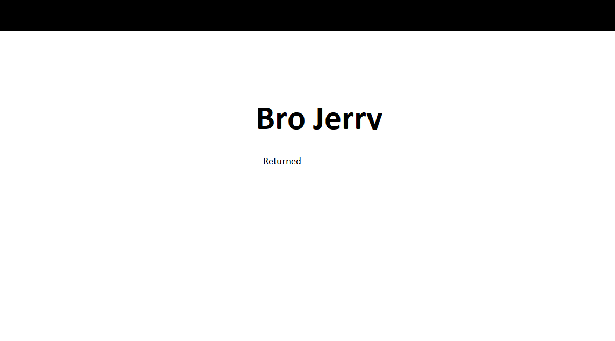

Task 2: Identify any classes required

*Bro class – holding all information for each bro*

Task 3: Identify information to be displayed

*Return page – Users inputs*

*Return success page – Product name*

Task 4: Identify user inputs

*Name, last name*

Task 5: Identify any constants or existing data if required

*Test Data will be created as well as a list of month words with corresponding numbers*

Task 6: Identify indexed data structures

*bros – Holds all Bro objects*

*months – Holds all month words with number keys*

Task 7: Determine what calculations are necessary

None

Task 8: Develop a modular structure for your program

*Describe any functions that the computer program will have, identifying any sub-functions where required.*

The only functions being created are the page functions containing page instructions and routing, and Static File import functions giving file directions.

Task 9: Define the functions identified

*Describe the functions for both the main program and any classes in terms of input and/or output where required. You may choose to do this with flow charts or pseudo-code (not Python code!). Add in additional steps or explanations using sequential, conditional, iterative statements where required. Identify global and/or local variables.*

Import bottle functions

Import datetime functions

Create Bro class:

Create constructor method passing name, description, image link, cost, stock and booked details(set to “” by default):

*Set all self.variables to passed varaibles*

*Self.name = name*

*Self.description = description*

…

Create months dictionary with month names as the key and the month number as the data

*‘Jan”:1,*

*“Feb”:2,*

…

Create bros class holding all bro objects:

Fill with test data

*Bro("Tom","…”,” tom.jpg", 970, True),*

…

Create index page function and routing using (‘/’)

Create product page function and routing using (‘/products.html’)

Return bros array to page to be displayed

Create purchase page function and routing using (‘/purchase.html’) with “name” as a parameter passed by the link

Create variable found_bro

Loop through every bro in bros array

Check if parameter name is the same as bro.name

Set found_bro to this bro

Set current_bro to found_bro

Return current_bro to page to be displayed

Create purchase_success page function and routing using (‘/purchase_success.html’) with method “post”

Collect all form data and store in apporopriate variables: Fname, LName and date_

Set variable Curr_date to current date using dateTime function

Set variable difference to the result of (date_ - curr_date)

Set variable total_cost to the resilt of (difference * current_bro.cost)

Set found_bro stock to False

Set current_bro booked details to the Fname, Lname, current date, date_ and total_cost

Return current_bro to page to be displayed

Create return_product page function and routing using (‘/return_product.html’)

Do nothing

Create return_success page function and routing using (‘/return_success.html’) with method post

Get form first name and store in Fname variable

Get form last name and store in Lname variable

Loop though every bro in bros array:

If current bros booked details matches fname and lname

Set found_bro variable

Change stock

Return bro

Route images from folder “./Images” using route “/img/<filename>”

Route Css files from folder “./Css” using route “/css/<filename>”

Route Script from folder “./Script” using route “/script/<filename>”

Call ‘run’ function passing port 399

Task 10: Address any relevant implications such as usability, functionality, legal/ethical requirements.

The user will be giving their name, so it needs to not be displayed to other users for privacy purposes. Controls must be obvious as page won’t have instructions. Buttons must be clearly labelled. Website uses simple colours so I will use a blue colour to make the return button obvious. Each input line will highlight when it is in use and go red if you have not successfully filled out. Links are all highlighted in colour.Error messages clearly tell the user what they need to do to fix it. Website is intuitive.

Task 11: Document test cases for testing the program

*Document any testing that can be used to test your program. If any input is inputted using the keyboard, describe the expected input, plus any exceptional, boundary or invalid cases.*

Try wrong names

Try right names

Task 12: Refine the plan

*Note any modifications here when iterating through the development cycles.*

Below fixes the site from breaking when the wrong names are inputed.

if found_purchase == None:

return dict(bro = False)

%if bro == False:

<h1>Sorry</h1>

<p>Could not find a booking under that name, please try again</p>

%else:

<h1>Bro: {{bro.name}}</h1>

<p>Returned by: {{bro.booked_details[0]}} {{bro.booked_details[1]}}</p>

%end

Task 13: Document testing

*Show screenshots of your program working with descriptions of each image. These images should test the tests cases listed above.*

|  |  |  |  |
| --- | --- | --- | --- |
| Test case | Expected outcome | Actual outcome | Solution |
| Try wrong names  (Any name that hasn’t been used to purchase a bro) | “Sorry could not find a booking under that name” | Crash bang page is gone | If not foound send a response to page so that it displays the right info |
| Try names that have been used to book | Tell the user what product was booked | Exactly what I expected |  |
|  |  |  |  |

Task 14: Evaluation

*How did your version turn out*

Turned out good, worked as I wanted it to with a few bug fixings.

Each product can be successfully returned by the purchasers first and last name. The design is intuitive and easy to navigate and simple to understand.

Through testing different inputs I found out that there were no error prevention. Through this method I found these errors and was able to fix them before I was to release the application.

By the end of this version I managed to make a system to return products to the store with error handling the unexpected inputs. Over all I would say this version has turned out as I wanted at works to the level required.